technical MEMORANDUM 1

|  |  |  |  |
| --- | --- | --- | --- |
| DATE: |  | November 07, 2022 | |
| TO: |  | Project Team | |
| FROM: |  | Kayla Fleskes-Lane, PE; John Bosket, PE | DKS Associates  Lewis Kelley, Rory Renfro, AICP | HDR Inc | |
| SUBJECT: |  | US 97 at Reed Market Road Operations and Safety Study  Study Background and Goals and Objectives | Project #22129-001 |

This memorandum introduces the US 97 at Reed Market Road Operations and Safety Study by explaining the problem and purpose; describing the area involved; providing an analysis of demographics in the area; and outlining the goals, objectives, and evaluation criteria that will be used to guide project decisions and select a preferred set of improvements. Appendix A of this memorandum includes a memorandum documenting key methods and assumptions to be applied to the analysis of transportation conditions.

# Project Problem and Purpose

The Oregon Department of Transportation (ODOT) is preparing a study to analyze operational and safety improvements for a segment of the Reed Market Road corridor within the City of Bend from Brookswood Boulevard/Bond Street to 4th Street. Reed Market Road was identified as a critical east-west travel corridor and priority for addressing mobility during the most recent Bend Transportation System Plan/Metropolitan Transportation Plan (TSP/MTP) update. As one of the few crossings of the Deschutes River and US 97, Reed Market Road is heavily relied upon for access to much of southern Bend, including popular destinations such as the Old Mill District, riverfront, Mount Bachelor, and Cascade Lakes Scenic Byway. The study corridor has multiple operations and safety deficiencies that compound to create a significant east-west bottleneck. Furthermore, one of the key findings from the US 97 Parkway Plan was that Reed Market Road congestion limits the ability of any interchange improvements to function adequately, leading to queue spillback and one of the most critical bottlenecks on the Parkway.

As a result of these earlier planning efforts, ODOT and the City of Bend partnered to identify and fund concept-level improvement projects in the Reed Market Road study corridor through the City’s Capital Improvement Program (CIP) and general obligation (GO) bonds. However, further project refinement and development of a coordinated plan are needed to support implementation. Therefore, the purposes of this study are to:

* Build upon the results of the Bend TSP/MTP and US 97 Parkway Plan and refine a set of complementary operational and safety improvement projects in the Reed Market Road study corridor that closely align with available funding.
* Develop planning-level concepts and updated cost estimates.
* Align existing project funding with proposed project costs and identify potential funding gaps.
* Provide a prioritized list of projects using a benefit/cost analysis.

# Project Study Area

Figure 1 shows the study area for the project. The study area includes six study intersections:

1. Reed Market Road and Brookswood Boulevard/Bond Street
2. Reed Market Road and US 97 Southbound Ramps
3. Reed Market Road and US 97 Northbound Ramps
4. Reed Market Road and Division Street
5. Reed Market Road and 3rd Street
6. 3rd Street and Brosterhous Road

Figure 1. Reed market road operations and safety study area

# Demographic Analysis

Demographic information is provided from the 2020 5-year American Community Survey and is presented in Table 1 (see the map of census block groups in Figure 2). Approximately 9,700 individuals live in the vicinity of the project area within 3,961 households, representing an average household size of 2.46 individuals. The median household income is $61,821 compared to $67,973 for the entire City of Bend. The lowest incomes are found in the neighborhoods immediately adjacent to Reed Market Road, while households west of Brookswood Boulevard significantly raise the median income of the area. Households with no access to private vehicles represent 16.5 percent in the area compared to six percent for the City of Bend. The high concentration of zero-car households is in part due to the presence of several retirement and care homes in the area. Of the 9,700 individuals, 13 percent identified as a minority, equal to the percentage in the City, 15.3 percent are 65 years of age or older compared to 17 percent in the City, and 12.3 percent live in households below the poverty level for the area compared to 10 percent in the City.

**Table 1: US 97 at Reed Market Road Study area demograpihc summary, 2020 5-year American community survey**

| Census Tract (block Group) | Total | 15.01(2) | 15.01(3) | 20.02(1) | 21.01(1) | 21.02(1) |
| --- | --- | --- | --- | --- | --- | --- |
| Household Data |  |  |  |  |  |  |
| Households | 3,961 | 1,022 | 635 | 925 | 420 | 959 |
| Housing Units | 4,558 | 1,075 | 714 | 956 | 444 | 1,369 |
| Zero Car Households | 652 (16%) | 249 (24%) | 98 (15%) | 72 (8%) | 216 (51%) | 17 (2%) |
| Population Data |  |  |  |  |  |  |
| Population | 9,732 | 1,873 | 1,204 | 3,288 | 979 | 2,388 |
| Minority Population | 1,256 (13%) | 324 (17%) | 191 (16%) | 445 (14%) | 142 (15%) | 154 (6%) |
| Population 65+ | 1,485 (15%) | 421 (22%) | 153 (13%) | 189 (6%) | 66 (7%) | 656 (27%) |
| Population Below Poverty Level | 1,197 (17%) | 204 (11%) | 30 (2%) | 571 (17%) | 147 (15%) | 245 (10%) |
| Income and Employment Data |  |  |  |  |  |  |
| Median Household Income | $ 61,821 | $ 45,324 | $ 45,858 | $ 61,250 | $ 62,234 | $ 93,438 |
| Employment | 4,489 | 1,103 | 716 | 1,296 | 489 | 885 |

*Source: 2020 5-Year American Community Survey.*

Figure 2 shows the census blocks and centers with high concentrations of employment or activities, such as the Oregon State University Cascades Campus or the Old Mill District. These centers attract high numbers of visitors daily or during events and generate traffic demand on Reed Market Road and the surrounding streets.

**figure 2: employment and activity centers in the Project Area**

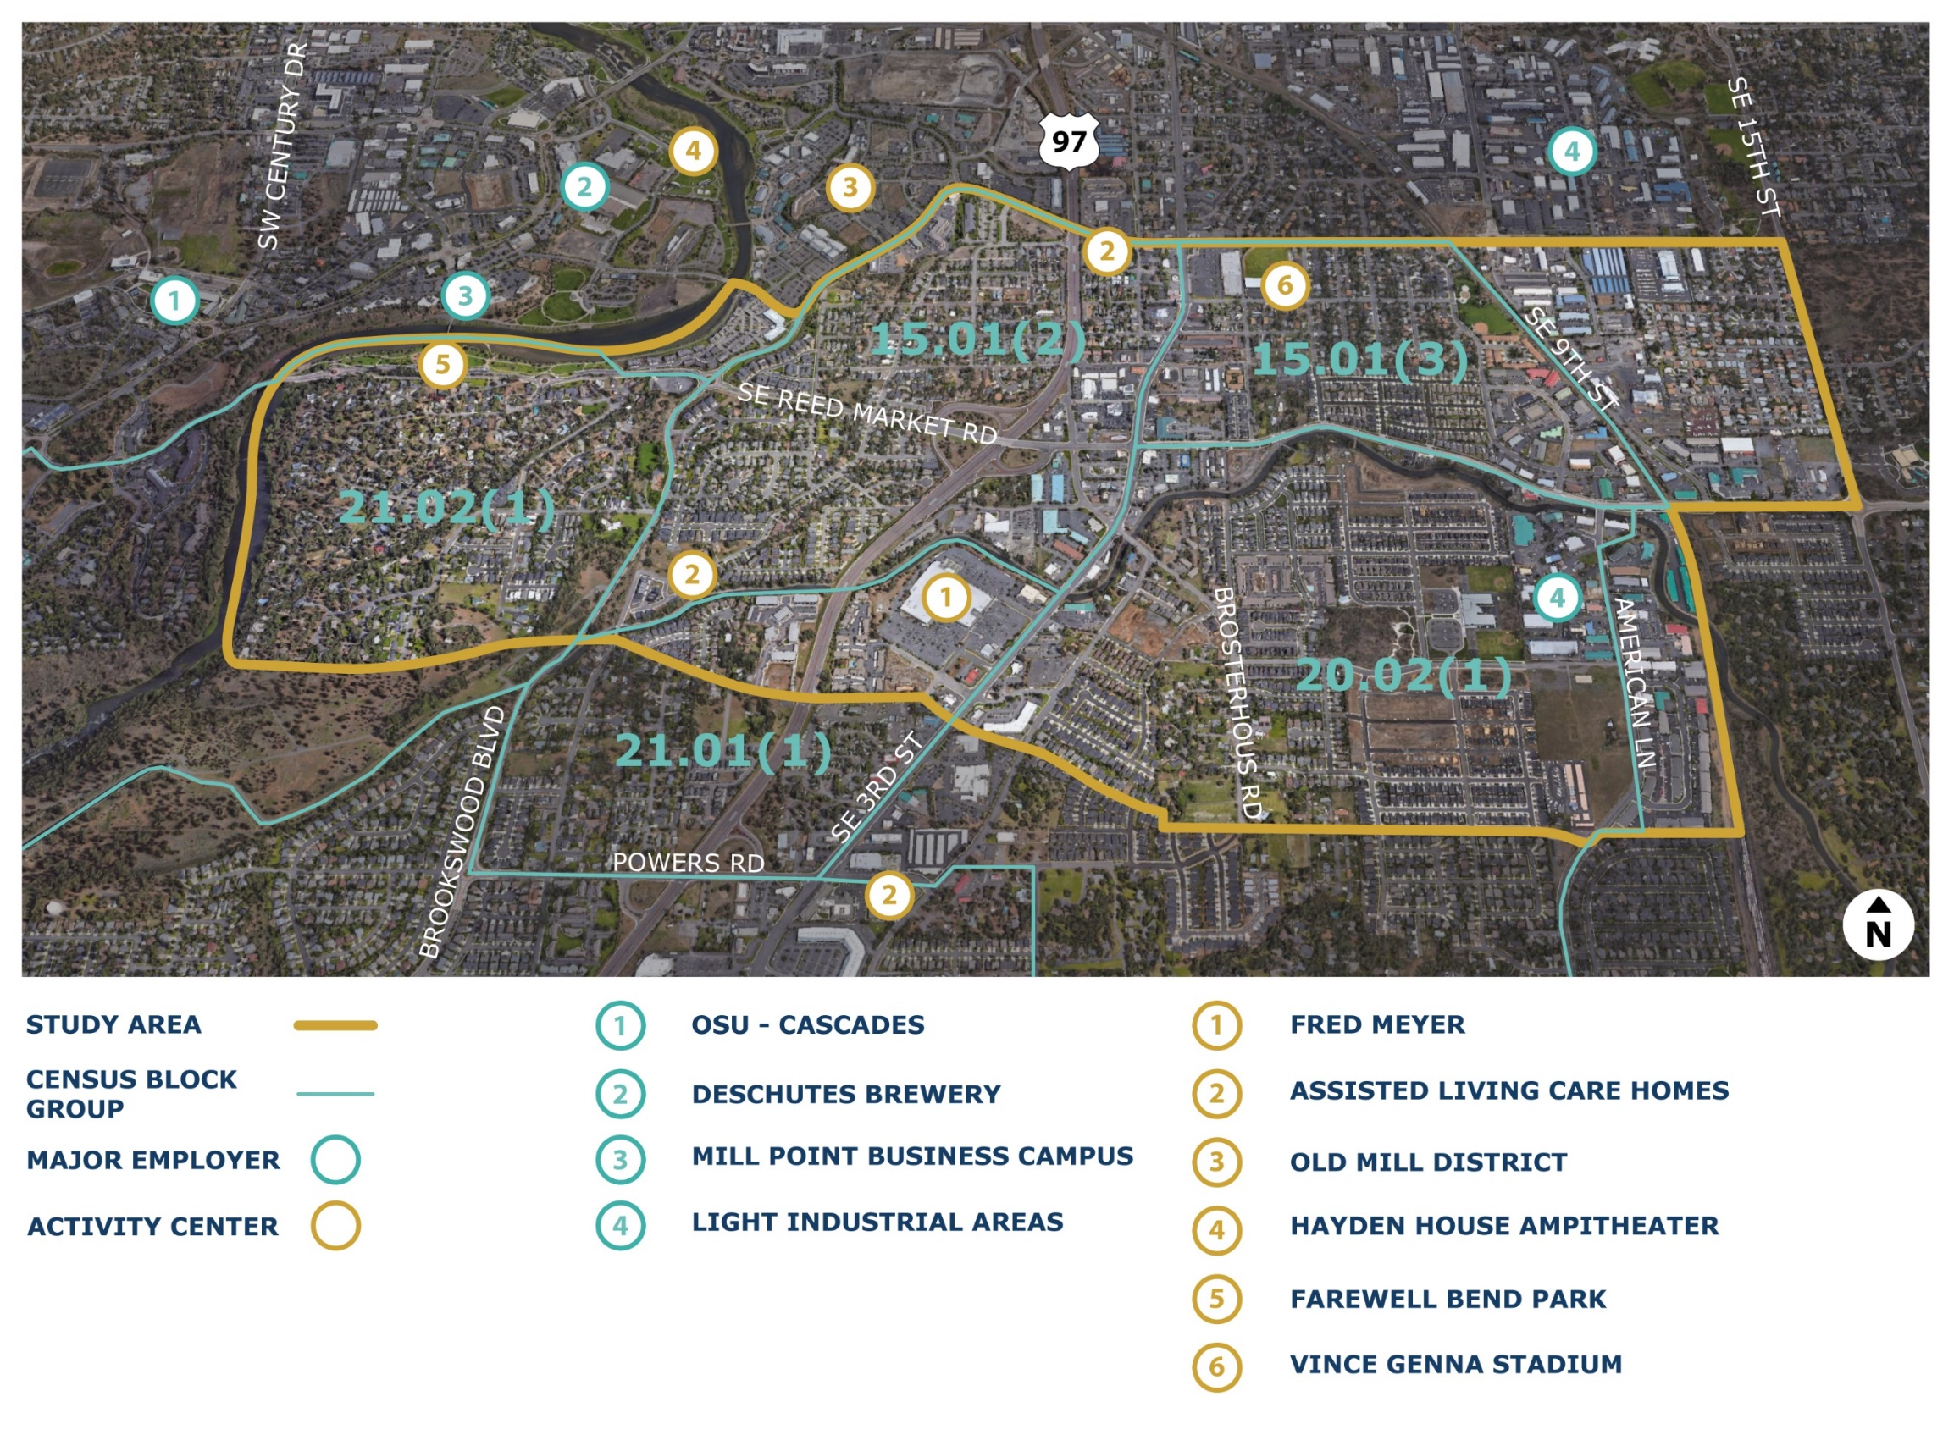

# Goals, Objectives, and Evaluation Criteria

A draft set of project goals, objectives, and evaluation criteria is provided in Table 1. A **goal** is an overarching principle or a broad statement of intent that informs the range of possible transportation solutions and guides decision-making. **Objectives** are more specific and relevant steps that are taken to meet the goal, while **evaluation criteria** assess how well those objectives would be met by the alternatives considered.

This initial set of goals, objectives, and evaluation criteria were developed with consideration to the project problem and purpose previously described, as well as the goals, objectives, and evaluation criteria from the Bend TSP/MTP and US 97 Parkway Plan (included in Appendix B for reference). As a next step, the goals, objectives and evaluation criteria will be refined through discussions with the project team and input provided by stakeholders. The resulting goals, objectives, and evaluation criteria will guide the development of solutions for the Reed Market Road study corridor and will be used to demonstrate how well improvement alternatives meet the purpose of the project.

The goals and objectives have been numbered to facilitate referencing, but no weighting has been applied, and the order is not an indication of relative importance.

**Table 1: US 97 at Reed Market Road Operations and Safety Study Goals, Objectives, and Evaluation Criteria**

| Goals | Objectives | Evaluation Criteria |
| --- | --- | --- |
| 1. Increase system functionality, quality, and connectivity for all users | a. Provide for efficient travel for traffic utilizing US 97. | Meets ODOT’s adopted mobility targets at the US 97 ramp terminals with Reed Market Road and Division Street through the planning horizon. |
| b. Provide for efficient travel on the local roadway system in the interchange area. | Meets City of Bend mobility standards for local system study intersections through the planning horizon. |
| c. Enhance bicycle and pedestrian facilities along, parallel to, and across US 97. | Based on qualitative criteria, enhances the quality of walking and biking facilities. |
| Increases the frequency of low-stress pedestrian and bicycle crossings of Reed Market Road. |
| Supports implementation of low-stress pedestrian and bicycle crossings of US 97. |
| Implements a planned low-stress bicycle network and key walking and biking routes in the study area. |
| d. Enhance transit facilities along, parallel to, and across US 97. | Can accommodate planned transit service improvements and expansions. including micromobility. |
| 2. Ensure safety for all users | a. Reduce serious injuries and fatalities. | Reduces the frequency and severity of crashes, as assessed through analysis of crash data and use of Crash Modification Factors. |
| b. Design and build facilities and routes that maximize safety for pedestrians and bicyclists. | Minimizes conflicts and risk factors that could lead to crashes. |
| Increases the physical separation between users. |
| c. Move toward meeting ODOT’s adopted access spacing standards along US 97, Reed Market Road, and Division Street, or meet the standards where feasible. | Meets or improves access spacing pursuant to ODOT’s adopted access spacing standards. |
| 3. Support economic development | a. Maintain effective access to properties along Reed Market Road and Division Street in a manner that supports the economic development objectives of existing and future businesses, consistent with the Bend Comprehensive Plan. | Maintains accessibility to properties consistent with the documented needs of existing land uses, City of Bend standards, and anticipated potential needs of future uses based on Comprehensive Plan designations. |
| b. Develop an interchange design that facilitates truck freight movement along US 97 and to and from destinations along Reed Market Road. | Proposed interchange geometry, such as curves, clearances, and grades, accommodates trucks and oversize vehicles while finding an appropriate balance with the needs of people walking and biking. |
| 4. Protect livability and ensure equity and access | a. Incorporate a complete streets approach along the Reed Market Road corridor through the interchange area. | Based on qualitative criteria, addresses existing barriers for people walking and biking across or along Reed Market Road. |
| Can accommodate planned transit service improvements and expansions. |
| b. Strive for people of all income levels and abilities to have access to the transportation options that best meet their needs. | Impacts to properties owned, used by, or accessed by historically underrepresented community members are proportionate to those of other populations. |
| 5. Steward the environment | a. Reduce vehicle emissions through reduction of vehicular delay, improved connections in the local system, and the use of alternative travel modes. | Qualitatively assesses reductions in vehicular delay and vehicle-miles traveled, as well as improvements supporting walking, biking, and use of transit. |
| 6. Develop solutions that are cost-effective and implementable | a. Prioritize low-cost, high-benefit solutions. | Based on qualitative criteria, finds solutions that are effective at addressing goals and objectives compared to costs and would reasonably fit within funding expectations for project partners. |
| b. Prioritize solutions that that leverage partnerships, existing planned projects, and programs. | Creates solutions that are compatible with recommendations from the US 97 Parkway Plan, Bend TSP/MTP, and planned Bend CIP/GO Bond projects and align with available funding. |
| c. Develop a design that is constructable in phases and could be reasonably maintained. | Can be implemented incrementally in functional phases. |
| Minimizes the number of potential design exceptions. |
| Does not create maintenance challenges. |
| Is easily constructable with regard to the ability to maintain movement of all modes during construction. |